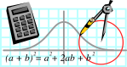  Rossmoyne SHS  Mathematics  Department | 2A MATHEMATICS | Semester 1 2011  EXAMINATION

NAME:
TEACHER: Mr. Fletcher Mr Tanday

Section One:
Calculator-free

Time allowed for this section
Reading time before commencing work: 5 minutes
Working time for this section: 50 minutes

Material required/recommended for this section

To be provided by the supervisor
This Question/Answer Booklet
Formula Sheet

To be provided by the candidate
Standard items: pens, pencils, pencil sharpener, eraser, correction fluid, ruler, highlighters

Special items: nil

Important note to candidates
No other items may be used in this section of the examination. It is your responsibility to ensure that you do not have any unauthorised notes or other items of a non-personal nature in the examination room. If you have any unauthorised material with you, hand it to the supervisor before reading any further.

Structure of this paper

Section | Number of questions available | Number of questions to be answered | Working time (minutes) | Marks available
Section One:  Calculator-free | 7 | 7 | 50 | 40
Section Two:  Calculator-assumed |  |  | 100 | 80
 |  |  |  | 120

Instructions to candidates

1. The rules for the conduct of Western Australian external examinations are detailed in the Year 12 Information Handbook 2011. Sitting this examination implies that you agree to abide by these rules.

2. Answer the questions in the spaces provided.

Section One: Write answers in this Question/Answer Booklet. Answer all questions.
Show all your working clearly. Your working should be in sufficient detail to allow your answers to be checked readily and for marks to be awarded for reasoning. Incorrect answers given without supporting reasoning cannot be allocated any marks. For any question or part question worth more than two marks, valid working or justification is required to receive full marks. If you repeat an answer to any question, ensure that you cancel the answer you do not wish to have marked.

It is recommended that you do not use pencil, except in diagrams.

3. You must be careful to confine your responses to the specific questions asked and to follow any instructions that are specific to a particular question.

4. Spare pages are included at the end of this booklet. They can be used for planning your responses and/or as additional space if required to continue an answer.
- Planning: If you use the spare pages for planning, indicate this clearly at the top of the page.
- Continuing an answer: If you need to use the space to continue an answer, indicate in the original answer space where the answer is continued, i.e. give the page number. Fill in the number of the question(s) that you are continuing to answer at the top of the page.

QUESTION | MARKS AVAILABLE | STUDENT MARK
1 | 7
2 | 4
3 | 5
4 | 6
5 | 8
6 | 4
7 | 6
TOTAL | 40

SECTION A
NO CALCULATORS PERMITTED FOR THIS SECTION
TIME 50 minutes
AVAILABLE MARKS 40 marks
Question 1 [2, 1, 2, 2 = 7 marks]
Sketch the graphs of the following lines:-
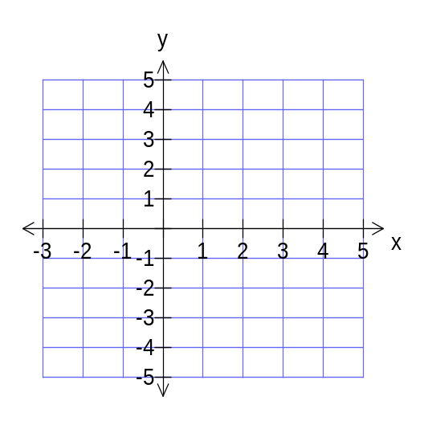  y = x - 4 | x = 3
y = –2x + 1 | 10x + 5y = 15

Question 2 [2, 2 = 4 marks]
Factorise each of the following:-
(a) 36x + 18y
(b) 16a² – 24ab
Question 3 [2, 3 = 5 marks]
Solve the following equations:-
(a) 5x + 4 = 19 (b) 3(x – 4) – 3x = 9 – 3(4 – x)

Question 4 [4, 2 = 6 marks]
Age of driver | 10≤x<20 | 20≤x<30 | 30≤x<40 | 40≤x<50 | 50≤x<60
Number of claims | 65 | 25 | 31 | 15 | 5

(a) On the axes below, draw a histogram of the data given in the table above.
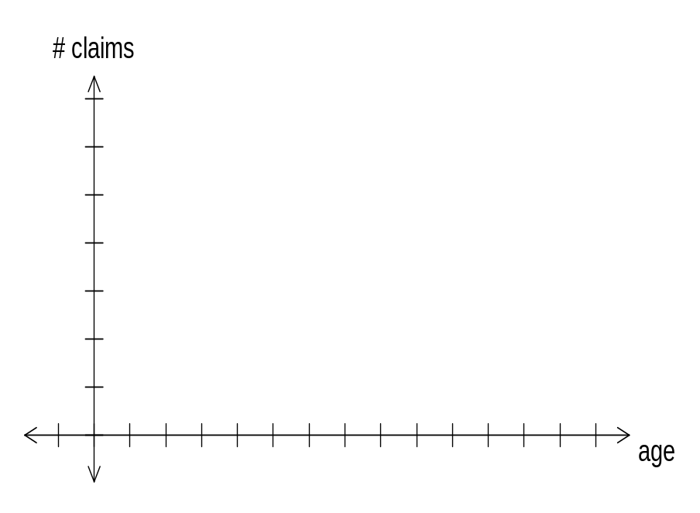

(b) On the histogram, sketch the frequency polygon
Question 5 [2, 2, 2, 2 = 8 marks]
Show the following transformations on the axes below:-
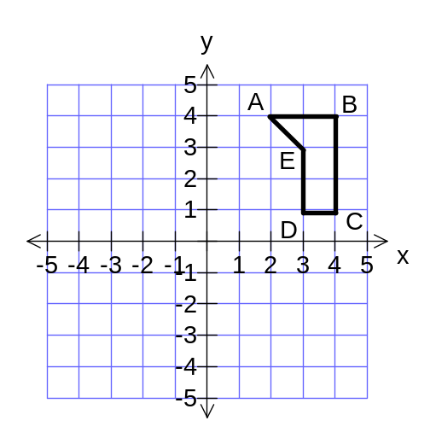  Translate A-E 4 units to the left | Rotate A-E 90º clockwise about A
Reflect A-E in the Y axis | Rotate A-E 180º clockwise about the origin ,point (0, 0)

Question 6 [4 marks]

Rebecca’s father is 5 years older than three times her age. If their combined age is 46 years, find the age of both Rebecca and her father.

[To gain full marks, working out must be shown].
Question 7 [1, 1, 1, 1, 1, 1 = 6 marks]

Scores on a test out of 10 were as follows for a class of students:-
Score | 5 | 6 | 7 | 8 | 9 | 10
Frequency | 2 | 5 | 10 | 8 | 4 | 3

Answer the following questions for the above set of scores:-
(a) How many students are in the class? _____________

(b) What is the mode? _____________

(c) What is the median? _____________

(d) What is the mean? _____________

(e) How many scores were more than 7? _____________

(f) What was the score of the 26th student from the bottom _____________

END OF SECTION A
GO BACK AND CHECK YOUR WORKING

